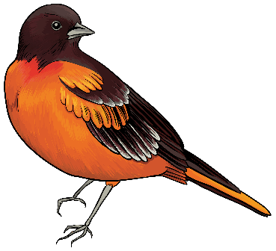
Spring
Craft / Vendor Fair

Sat, May 11th, 2024

Outdoor Space $25 – w/table $35
Indoor Space $35 – w/table $45

Hosted by and proceeds benefit:
Glen Burnie Volunteer Fire Company
1012 Bell Avenue – Glen Burnie, MD 21060
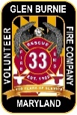
410-793-2709

